Ch 10: Three Level Models

**Case study: Seed Germination**

In recent years, prairie reconstruction projects have become commonplace in many areas that were once primarily agricultural fields. Recent reconstruction projects at a small Midwestern college have yielded varying plant communities despite using similar seed combinations and dispersal techniques. Thus researchers decided to explore the underlying causes of this variation in order to make future reconstruction projects more effective, organizing longitudinal data collection by introductory ecology classes. Primarily, the researchers compared germination and growth of two species of prairie plants—leadplants (*Amorpha canescens*) and coneflowers (*Ratibida pinnata*)—in soils taken from a remnant prairie, a cultivated field, and a restored prairie. Additionally, half of the sampled soil was sterilized to determine if rhizosphere differences were responsible for the observed variation.

The experiment was run using a 3x2x2 factorial design, with 3 levels of soil type (remnant, cultivated, and restored), 2 levels of sterilization (yes or no), and 2 levels of species (leadplant and coneflower). Each of the 12 treatments (unique combinations of factor levels) was replicated in 6 pots, for a total of 72 pots. Six seeds were planted in each pot (although a few pots had 7 or 8 seeds), and the height of each germinated plant (in mm) was measured at 13, 18, 23, and 28 days after planting. The data is found in wide form in **seeds2.csv**, and relevant R code can be found under **ThreeLevelAug19.Rmd**.

1. The patterns of missingness tell an interesting story in this data set. Describe trends you observe.

2. Give an example of a Level Two covariate that could have been recorded in this study.

3. What are the advantages to centering our time variable (at Day 13)?

4. According to boxplots, are the effects of soil type and sterilization similar for leadplants and coneflowers? Explain.

5. What trends do you observe in the spaghetti and lattice plots? Is linear growth reasonable? Is there more variability among intercepts or slopes? What differences do you observe between species, soil types, and sterilization?

6. Do boxplots of intercepts and slopes confirm your observations from (5) about the differences between species, soil types, and sterilization?

7. We now wish to fit a taxonomy of models to this data, beginning with an unconditional means model. If we define  as the height of plant *j* from pot *i* at time *k*, then the unconditional means model is:

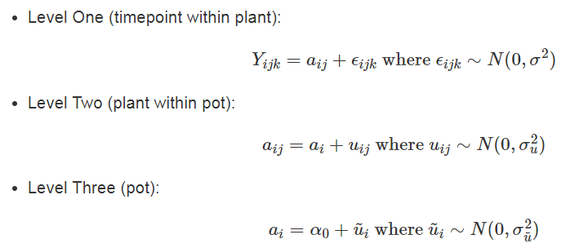

Describe the meanings of the following terms in context: , , , , , .

8. What strategies are available when your parameter estimates run into boundary constraints?

9. How many parameters must be estimated in Model Cplus (without peeking at BYSH), assuming full error covariance matrices at each level (note: this assumes we have data on seedsize):

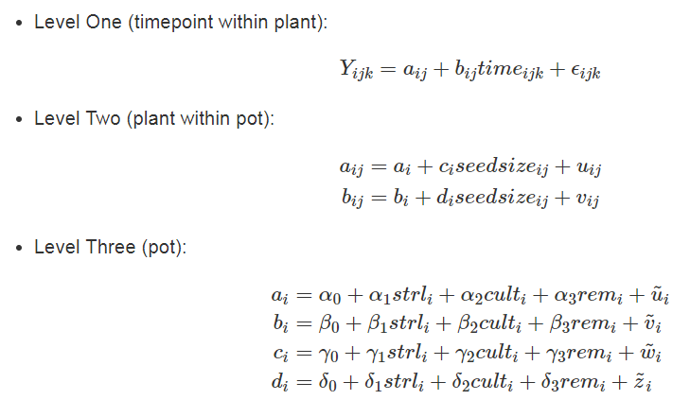

10. How many additional parameters must be estimated if we simply add an extra Level One covariate to Model Cplus in (9)?

11. Describe options for reducing the number of parameters if a model seems like it has too many paramenters.

One potential final model for the Seed Germination data is given below. In the questions that follow, select the *best* interpretation for specific parameters out of the choices given.

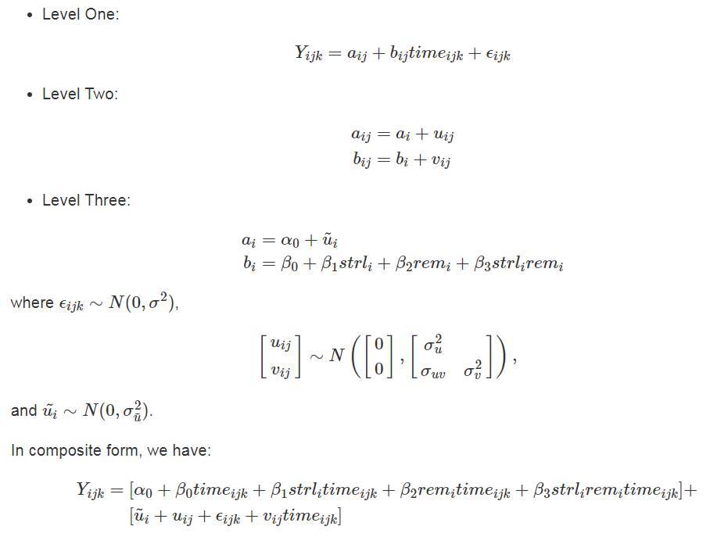

12. ${\hat{α}}_{0}=1.529$

a) Mean height for leadplants 13 days after planting.

b) Mean height for leadplants 13 days after planting, controlling for sterilization and soil type.

c) Mean height for leadplants 13 days after planting in restored prairies or cultivated lands with no sterilization.

13. ${\hat{β}}_{0}=0.091$

a) Mean daily change in height for leadplants from 13 to 28 days after planting.

b) Mean daily change in height for leadplants from 13 to 28 days after planting, controlling for sterilization and soil type.

c) Mean daily change in height for leadplants from restored prairies or cultivated lands with no sterilization from 13 to 28 days after planting.

14. ${\hat{β}}_{1}=0.060$

a) Leadplants grown in sterilized soil have an estimated daily increase in height of 0.151 mm.

b) The increase in mean daily change in height for leadplants from sterilized soil compared to unsterilized soil, controlling for soil type.

c) The increase in mean daily change in height for leadplants from sterilized soil from restored prairies or cultivated lands, compared to unsterilized soils of these types.

15. ${\hat{β}}_{3}=-0.039$

a) Leadplants grown in sterilized soil from remnant prairies have an estimated daily increase in height of 0.095 mm.

b) The mean daily change in height for remnant prairies is an additional .039 mm/day smaller than the mean daily change for other soil types when soil has been sterilized.

c) The decrease in the effect of sterilization on mean daily change in height for remnant prairies as compared to other soil types.